Philadelphia, Atlanta, Dallas, San Diego, and New Orleans. According to company estimates, its own sales organization reaches approximately 70 per cent of the world market. In the upcoming years, ReadSoft intends to establish its own sales organizations in Japan and one other Asian market.

License income by market (%)
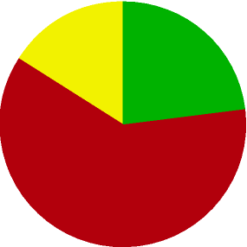
Sweden 23% Europe 61%
Other markets 16%
License revenues by product (SEK m)
FORMS
INVOICES
Licenses
Service contracts, development, education Hardware, other
9
The function of the subsidiaries is to market and sell ReadSoft products and to provide support on local markets. Our sales and marketing strategy is to sell the company’s products to customers both directly and through distributors. A local presence provides increased focus and yields greater control of sales than selling solely through local resellers. In this way, ReadSoft can achieve a high level of market penetration for all products. Being able to break into strategic markets quickly and take market share is of decisive importance to the company’s position and strength.
An untapped global market
The market for automatic data capture is young, its growth to date primarily having been spurred by technological development. The market has tremendous potential, and is thus far largely untapped. Today, only a fraction of data entry from documents is carried out automatically in the business world. The primary customer benefits to be derived from investing in an automatic data capture system are:
- reduced data entry costs as the amount of manual work is reduced
- increased accuracy in the entry process
- shorter entry times
- improved capacity to deal with seasonal variation
- a better working environment through the elimination of monotonous tasks
According to a report by Wood Associates, the expense of data entry from paper documents – that is, the cost

